Header :- Remove Enquire on whatsapp button

1. For hero section use Villa Raag video - Villa-Raag-hero-video.mp4
2. images/Hero section content:
Remove This line :-- Experience the best villa in Agonda—secluded, luxurious, and few meters from the beach. Book Now for exclusive inaugural rates!
3. Add Floating icon whatsapp - lets talk link:- https://wa.me/919289838797?text=Hi%20Villa%20Raag%2C%20I%27d%20like%20to%20enquire%20about%20a%20private%20stay.

4. Add These Testimonials
Refernce image this will be slider
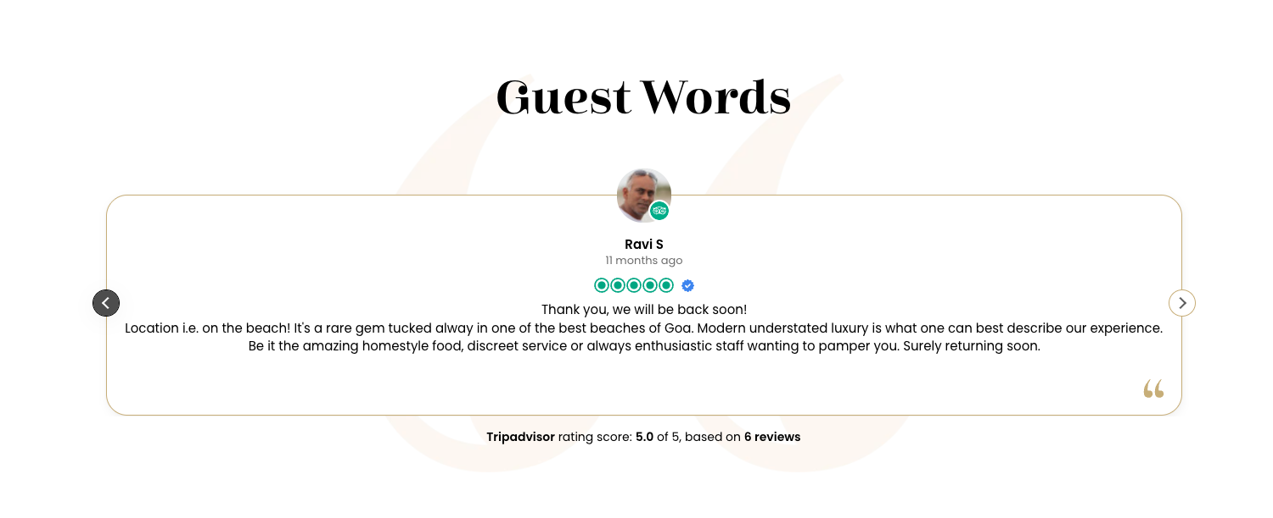
1. Catriona B
Highly recommend
Really attentive service and delicious healthy Goan food, some of the best we had on our trip. The space and design is modern, light and airy, with comfy beds and a beautiful pool area. The yoga area hadn't opened when we came but I imagine it would be a lovely place to practice. Would recommend if you're looking for something luxurious in Agonda

2. Praveen R
Fantastic Stay
We had a fantastic stay at Villa Raag in Agonda. The ambience was so stylish and beautifully designed yet relaxing — it felt like a real escape from the world and the beautiful pool was truly an escape . Every meal we had was sourced locally, very flavourful and memorable, and the staff went out of their way to make us feel welcome and comfortable. Just footsteps from the beach would strongly recommend Villa Raag to anyone looking for a peaceful beach getaway in Goa.

- Garima M
Wonderful experience at Raag
Our stay at Raag was absolutely delightful! The property is beautifully designed with a perfect blend of modern comfort and Goan charm. Its location—just a short walk from the beach—makes it ideal for anyone looking to unwind and enjoy the sea breeze. The rooms were spacious, clean, and tastefully decorated, with thoughtful touches that made us feel at home. The staff was warm, attentive, and always ready to help with a smile. The serene ambience, lush greenery, and peaceful surroundings made it a truly rejuvenating getaway. Would highly recommend Raag to anyone looking to spend quality time with friends and family.
4. Ravi S
Thank you, we will be back soon!
Location i.e. on the beach! It's a rare gem tucked alway in one of the best beaches of Goa. Modern understated luxury is what one can best describe our experience. Be it the amazing homestyle food, discreet service or always enthusiastic staff wanting to pamper you. Surely returning soon.

5. Enquiry form
A. Make the date Start date from end date selector available.
B. Write Additional remarks (optional) instead of How can we help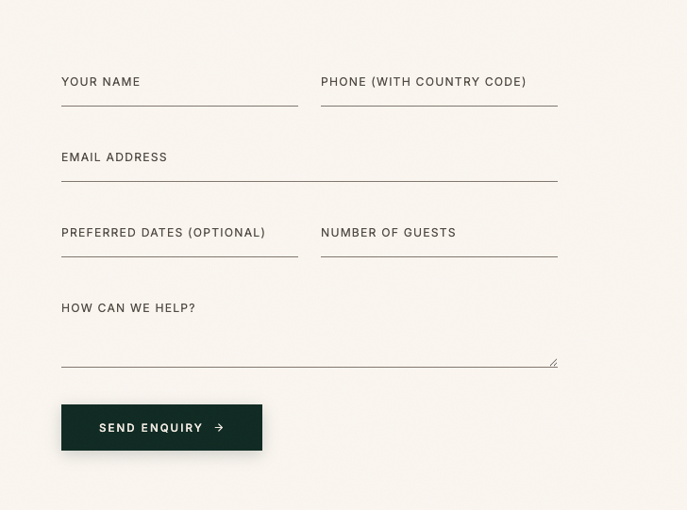

6. Remove full stop from Begin your stay with a conversation and make this line in center of section label Reservation also will be in center and then we respond line in left and on right side form
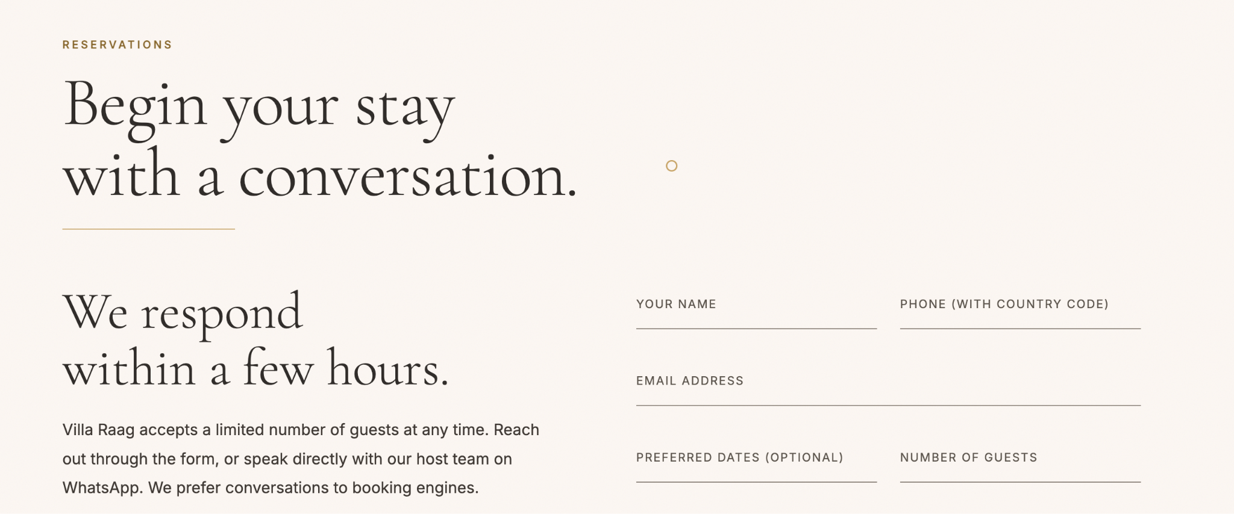

7. A. Headline: Write Exclusive Yoga & Wellness Experiences instead of Exclusive Yoga & Wellness programs coming soon
B. Label: Write Future Programs instead of wellness


8. Heading :- 60% Off & Exclusive Privileges for Inaugural Guests
Subheading :- Reserve your private villa at Villa Raag during our launch period only and enjoy a 60% privileges rate—plus gourmet experiences, and luxury enhancements reserved only for our first 50 guests.


60% Off & Exclusive Privileges for Inaugural Guests
Reserve your private villa at Villa Raag during our launch period only and enjoy a 60% privileges rate—plus gourmet experiences, and luxury enhancements reserved only for our first 50 guests.

